The X-Drive is a storage array, “A group of hard drives built into a single unit” configured in a RAID architecture for redundancy and speed. As a college resource, this device has a total of 35TB. Configured as network-accessible storage, this array is running out of space, putting this device at risk for the entire college. As such, we request ACOB users transition personal files or data requiring less drive performance over to One Drive. Departmental and shared folders should be moved to Microsoft Teams, and Research Data should be moved to ARC and Isilon.
Features of the X-Drive and use case.
- New accounts must be approved through Academic Computing and then forwarded to the tech café.
- Users will be limited to 500GB
- Backups are run daily, retention to backup 4 weeks.
- Primary use is for smaller data used for teaching and research
- Internal use for college administration, such as the Business Services Center
- DEFRAC review members
- Marketing and Communications

Use case for X:\ Drive?
  - Individual users should limit use of the resource to data requiring faster drive speeds or storage when running programs such as SAS, STATA, R and Python and using the VDI.
  - Communication and Marketing use of programs such as Adobe Premiere Pro where linked pictures and files require larger storge capacity and drive performance.
  - College administrative functions such as the DEFRAC review and Faculty awards review.

Contents
Request Access 3
Accessing the X Dive 3
Windows Access 3
Apple Location 5
Connect to the VPN 6
What is a VPN 6
How do we access the UTSA VPN? 6
Mapping the X Drive 8
Map the X Drive on Windows 8
Map the X Drive on Apple 10

Request Access

You can use the form in the link below to submit an X Drive Access Request.
- https://forms.office.com/r/Jze7tbfRA6

Accessing the X Dive
You will need to connect to the VPN if you are off campus.
- Steps can be found here.
If you are on campus connected using a desktop or your laptop is connected to fac-staff wi-fi, you do not need to do anything.

Windows Access
If you have access, it should be in file explorer.
- Go to file explorer.

- Go to this PC.
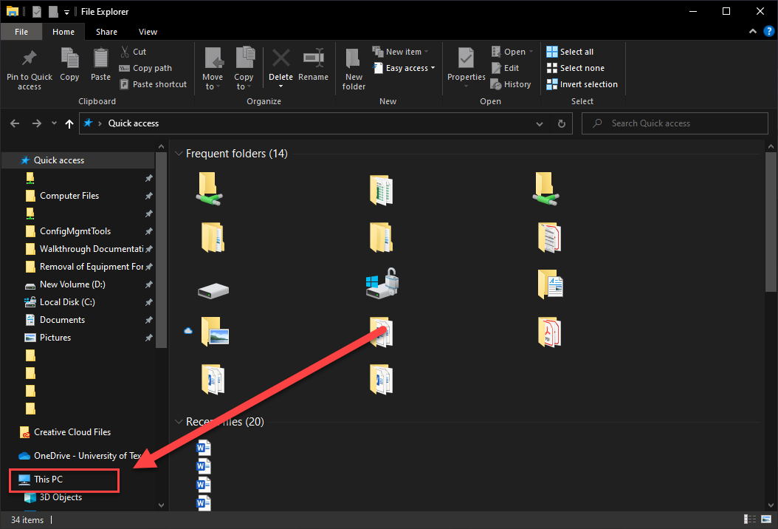

- The X Drive would be listed here.
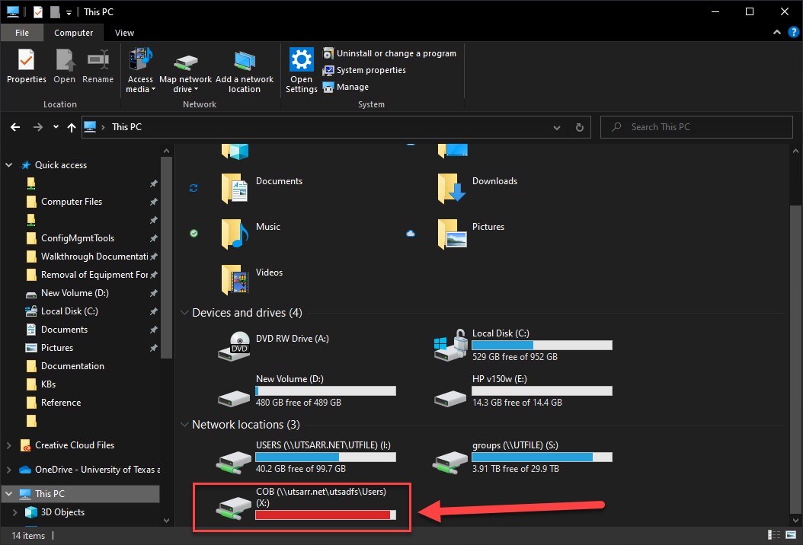

Apple Location
- Open Finder.
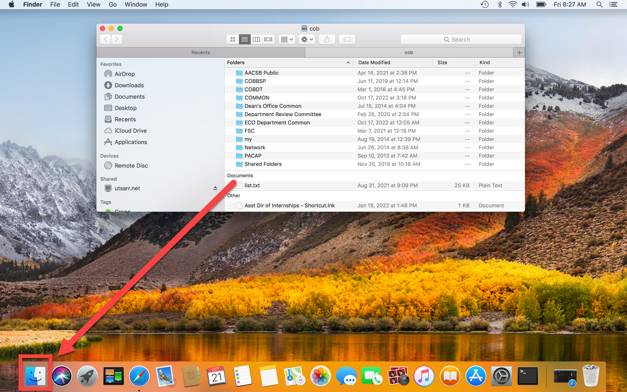

- If the X Drive is mapped, you will find it under “Shared.”
  - If you don’t see it, you may need to map it.
    - See instructions here.
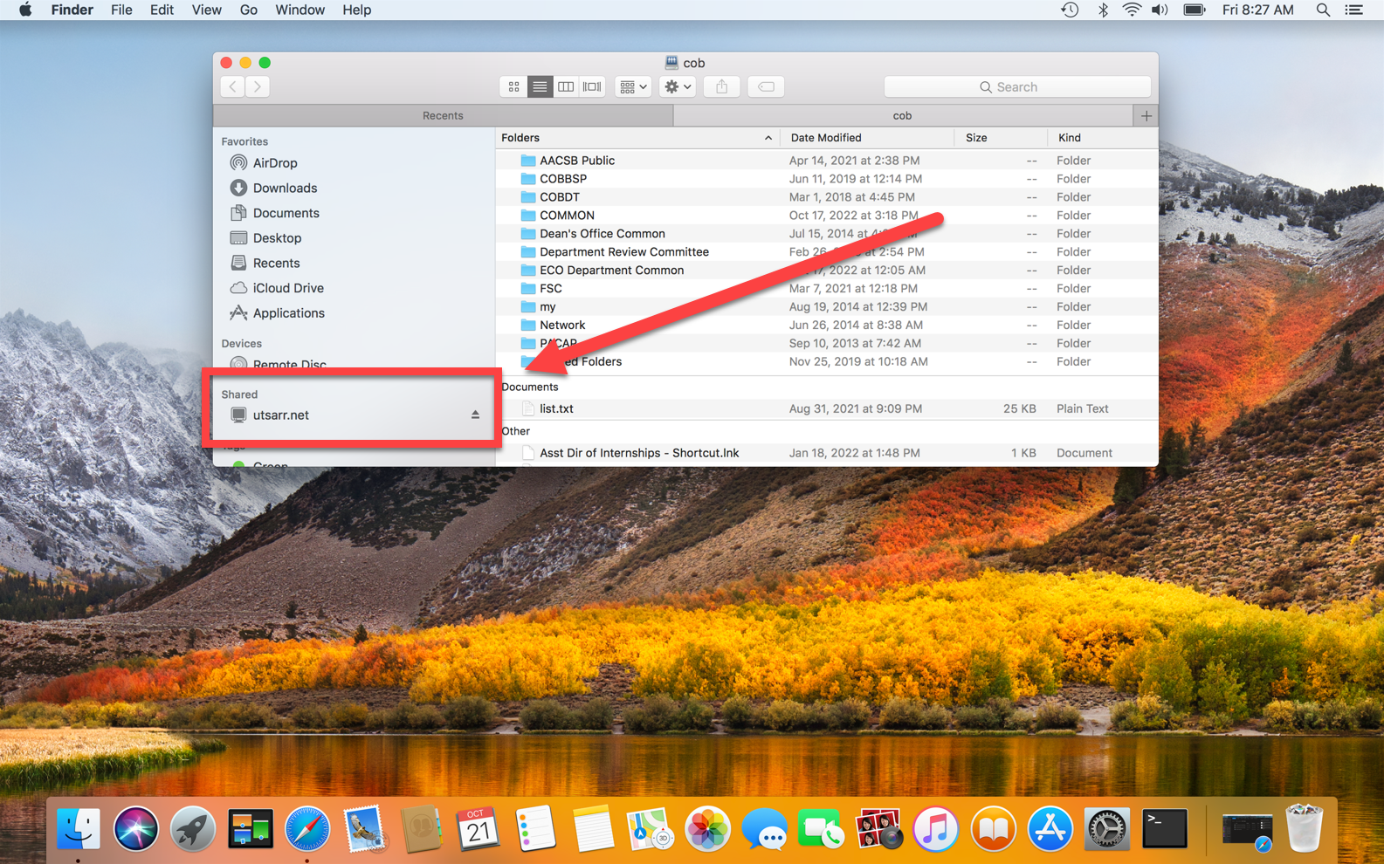

Connect to the VPN

What is a VPN
What is a VPN connection, and why are so many people talking about it? The term crops up in every conversation about the internet lately, and for a good reason. While VPNs were once novel tech solutions, they are now necessary tools. At the basic level, VPNs protect your privacy online, so you cannot be targeted, tracked, or discriminated against based on location.
A VPN works like a shroud of disguise, masking you in anonymity. You are trading your identifiable light cycle for a rented car with tinted windows. You are cloaked in data encryption and safely hidden behind a false IP address.
The VPN encrypts everything you do online, everything you send and receive. By accessing the web only through a VPN gate, the source of your connection is shown as one of the many VPN routers, not your own.
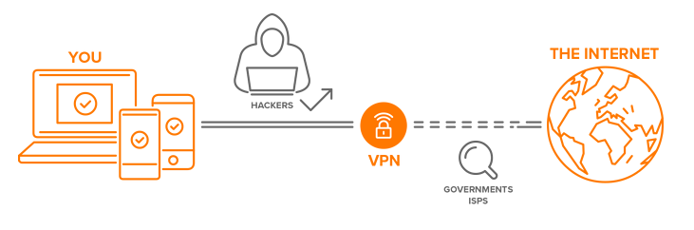

How do we access the UTSA VPN?
- First, we need to select the appropriate browser.
  - Windows systems
    - Use the browser Mozilla Firefox or Google Chrome.
  - For Macintosh products :
    - Use Safari 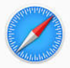 or Firefox.

- Next, in your browser, type in the address https://vpn.utsa.edu/my.policy
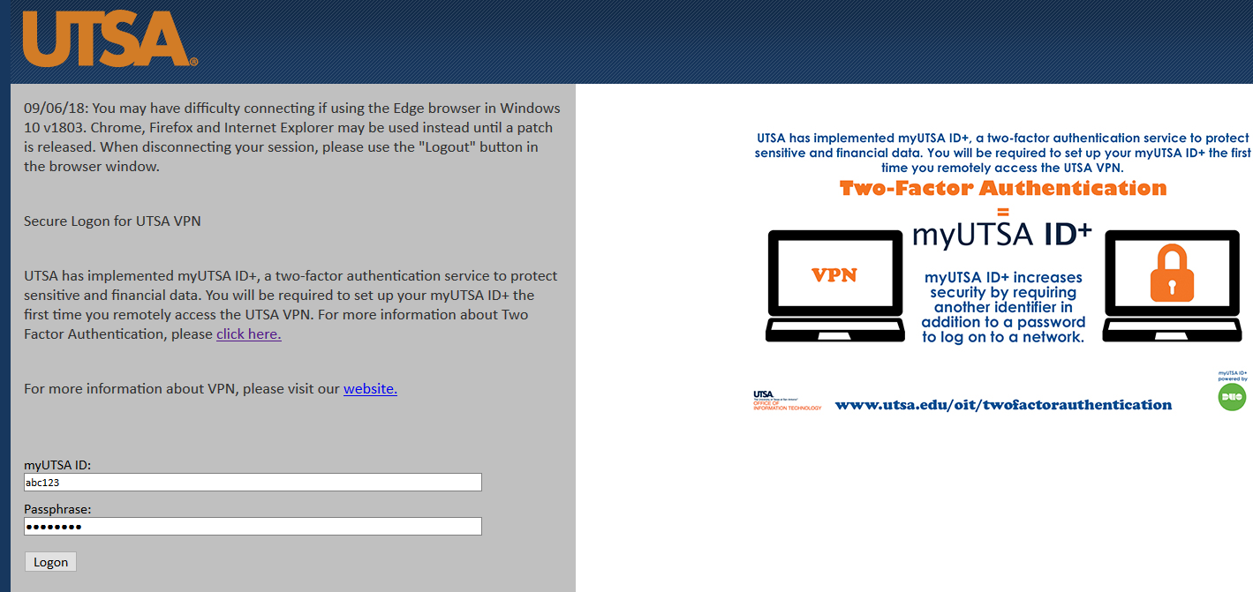

- Once you log in, it requires the Duo Factor Authentication process, which can call the phone on file with the Duo Factor Authentication process or send you a push notification.
  - If you do not have the Duo setup complete, click this link to begin the setup
https://security.utsa.edu/duo-setup/

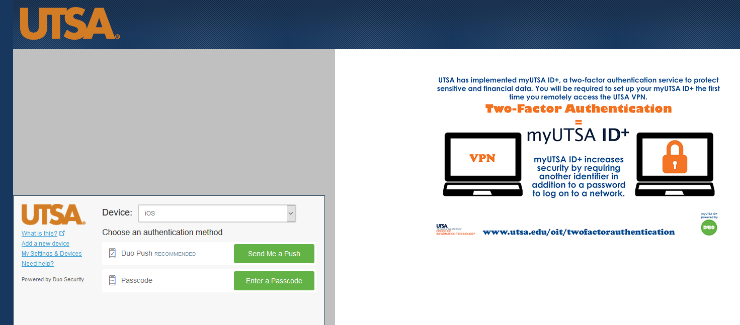

- The next thing that occurs is that when this connection is created between the offsite and the university network, you can access resources from network storage (X Drive), remote desktop connections (RDP) to your office computer, etc. ( please get with Academic Computing to configure your desktop to allow this feature)

Mapping the X Drive
- Windows Devices
- Apple Devices

Map the X Drive on Windows
- Open File Explorer
- Right-click on This PC and select Map Network Drive
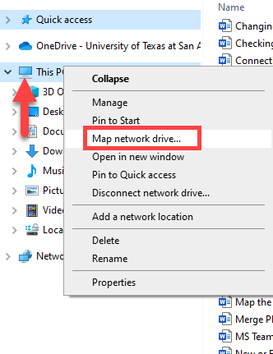
- Select X for the drive letter and type in \\utsarr.net\utsadfs\users\cob
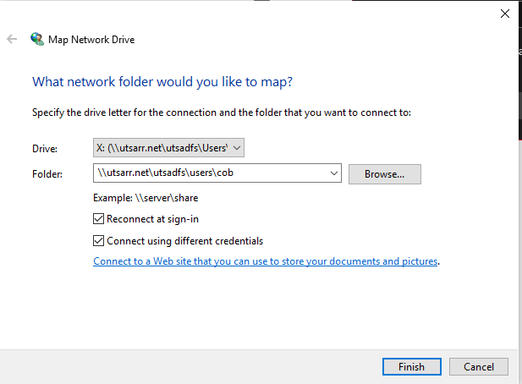
- In the pop-up, type utsarr.net\ and then your abc123 (as pictured below), your password, and then okay.
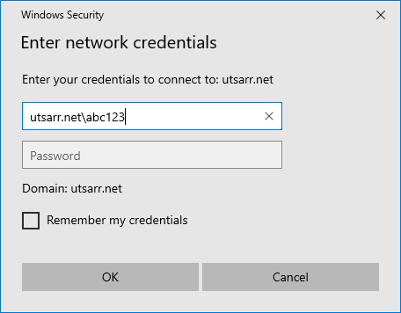
- The X Drive will automatically open a window if the connection is successful.
  - If you receive an error message, confirm the following.
    - You are connected to the VPN.
      - Steps can be found here.
    - You have been granted access to the X Drive.
      - Do you have an email confirmation of access?
      - Have you requested access?
        - https://forms.office.com/r/Jze7tbfRA6

Map the X Drive on Apple
- At the top left, where it says “Finder,” go to the “Go” tab and select “Connect to Server.”
  - If you do not see finder, click on a blank space on the desktop.
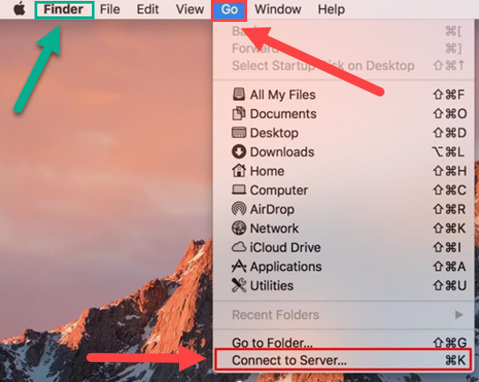

- In the next window, type in the following: utsarr.net/utsadfs/users/cob
  - Be careful to use “/” and not “\.”
  - Smb://should automatically fill in later.
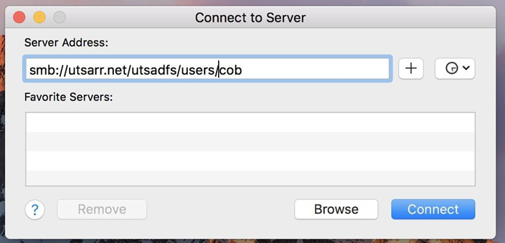

- When the next pop-up happens, click “Connect.”
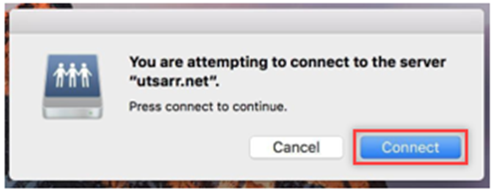

- Next, you will be prompted to log in.
  - Make sure that “Registered User” is selected.
  - Add “utsarr\” before your abc123.
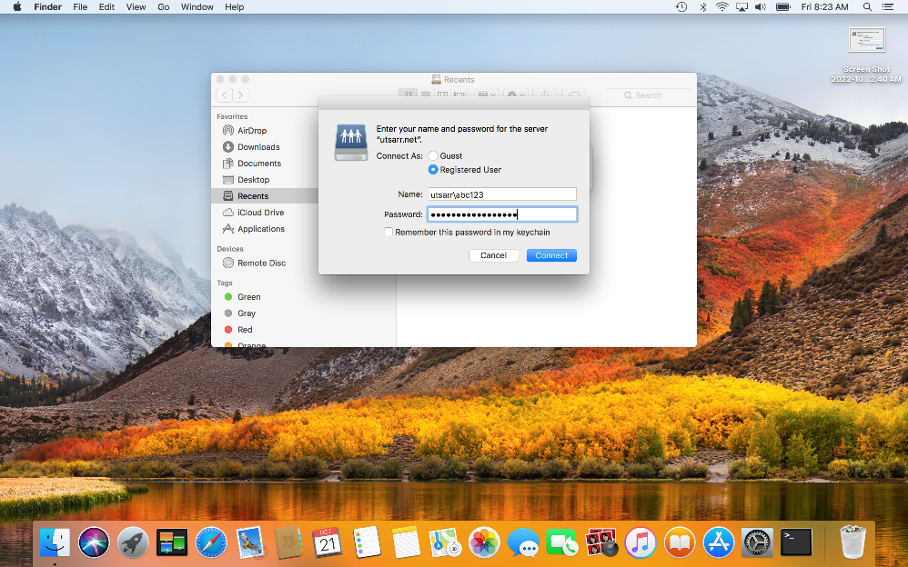

- The finder window will open with the X Drive if you have access.
  - If you receive an error message, confirm the following.
    - You are connected to the VPN.
      - Steps can be found here.
    - You have been granted access to the X Drive.
      - Do you have an email confirmation of access?
      - Have you requested access?
        - https://forms.office.com/r/Jze7tbfRA6
